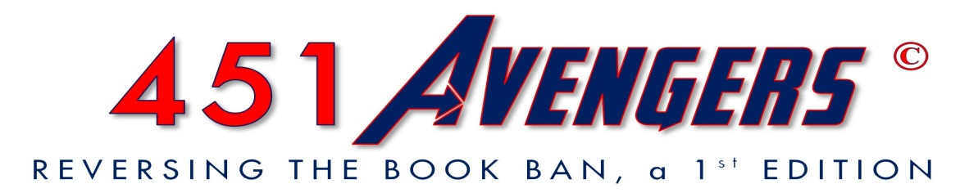​

﻿



**Truth or Fiction: The Facts of Book Banning**

**Save the Date!**

**Special Movie Showing**

***“Are You There, God?  It’s Me, Margaret.”***

**TUESDAY, May 2, 7:15pm / Movies of Delray**

7421 West Atlantic Avenue, Delray Beach, FL

∞∞∞∞∞∞∞∞∞∞∞∞∞∞∞∞∞∞∞∞∞∞∞∞∞

***Special Presentation:***

Film adaptation of Judy Blume’s iconic coming-of-age novel, ***“Are You There, God?  It’s***

***Me, Margaret.”*** Originally published in 1970, the book still remains on the "'most

challenged list" because of its focus on puberty.

**Panel Discussion following movie:** To increase awareness and provide

information about the current Florida book banning bills and initiatives.

***Featuring:***

**Rabbi Barry Silver, Moderator.** Civil rights attorney, singer-song writer, former

legislator, and founder of the Temple of Understanding. He has appeared on all national

media and is listed in Who’s Who for his outstanding contributions to the betterment of

society.

**Katherine Green, Reference and Instruction Librarian**. Lynn University, Boca Raton

*Additional panelists will be announced.*

***Cost:* Movie ticket price paid @ door*.***

***Seating:*  First come, first served.**

*For more information, please visit**www.moviesofdelray.com**.*